CST 229 – Lecture 6
Wilsonville, Fall 2017

Ch 16-17: context free vs. non-CF

Non-Context Free Languages
Not all languages are CF, Context-Free

For an infitite language to be CF, it must have repeating structures like the following…

Pumping Lemma for CF Languages (pg. 360):

If G is any CFG in CNF with p live productions, and w is any sentence generated by G with length greater than 2^{n}, then we can break up w into five substrings:
w = uvxyz
such that x is not λ, and v and y are not both λ and such that all the sentences
uv^{n}xy^{n}z { n = 1, 2, 3… }
can also be generated by G.

What does this mean?
Some clues…

Clue 1: CNF is Chomsky Normal Form, where all producitons are S→AB or S→terminal

Clue 2: Live Productions are those like S→AB, Dead Productions are like S→terminal

Clue 3: “Can be generated by” means that… eventually a sentence can be generarated by applying some sequence of productions in the CFG

Right, but what does it actually mean?

Remember the Pumping Lemma for REs?
There we could actually have no correlation before/after an infinitely repeating symbol

ThisPmping Lemma means that CFGs can create infinite sentences where you can correlate at most two infinitely repeating symbols

Why?

Because the best we’ve got is a stack for memory

When we use the stack to correlate parts of a sentence, we…
Build up state on the stack while processing the first repeating section
And then tear down the stack while processing the second repeating section

Example:
How would we create a PDA for the following language?

L = {a^{n}b^{n}a^{n} for n=1, 2, 3…}

How about the following?

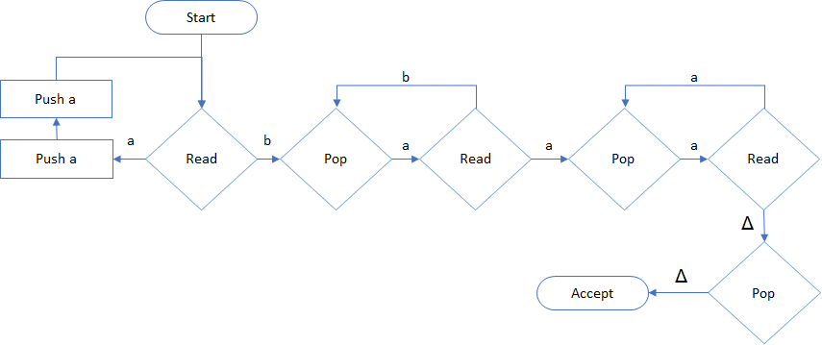

Try this out for aabbaa… it accepts it! 😊

Now try it out for aabbba… oh, it accepts that too. ☹

Why?
Because we cannot know if the b-matching actually uses up half the a’s on the stack

This language is Non-Context-Free… non-CF
Moreover, whenever we try to specify a language with restrictions between different parts of the sentence, with a CFG, we find that we cannot be completely selective…

Theorem 34 (Pg. 370)

If w is a sentence in a context-free language L and w is long enough, then w can be dcomposed into five parts: w = uvxyz, such that all the sentences uv^{n}xy^{n}z must also be in L.

Useful Properties of CFLs
If L₁ and L₂ are both CFLs, then…

The union, L₁ + L₂, is also a CFL

To create the union, we just need to OR, ‘|’, the starting symbols together…

L₁ defined by S₁ → A₁B₁, A₁→…
L₂ defined by S₂ → A₂B₂, A₂→…

L = L₁ + L₂ is defined by S → S₁ | S₂

This is helpful when designing languages
We can design in parts and assemble them together!

Here’s another handy combination…

The product, L₁ L₂, is also a CFL

To create the product, we just need to concatenate the starting symbols together…

L = L₁ L₂ is defined by S → S₁ S₂

And…

The Kleene Closure, ‘*’, (L₁)*, is also a CFL

To create the Kleene Closure, we play a neat trick, by adding a new starting symbol…

L = (L₁)* is defined by S → S₁ S | λ

This allows us to optionally repeat any sentence generated by S₁ as many times as we like
For example…

L₁ is defined by S₁ → aS₁a | bS₁b | a | b | λ
L = (L₁)* is defined by…
S → S₁ S | λ
S₁ → aS₁a | bS₁b | a | b | λ

What kind of sentences do we get out of language L?

